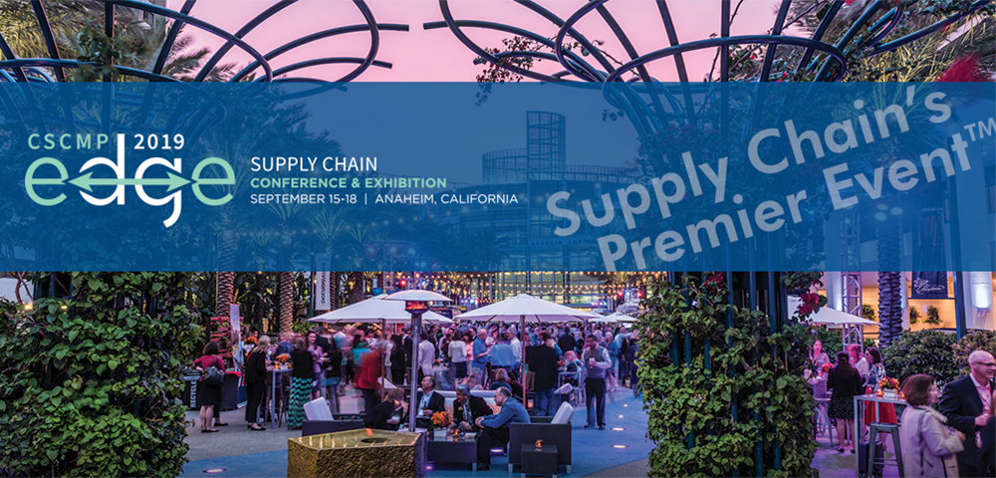

Apply for the CSCMP Future Leaders Program!

The SoCal CSCMP Roundtable will sponsor several CSCMP student members to attend the 2019 CSCMP Edge Conference in Anaheim as a “Future Leader”

BENEFITS TO STUDENTS

- An all-expense paid experience of a lifetime!
- Connect with supply chain peers around the globe.
- Attend educational sessions to learn from seasoned professionals.
- Participate in CSCMP’s 2019 Future Leaders Career Day & Workshop.
- Networking opportunities with future employers.

ELIGIBILITY

The principal requirements for sponsorship as a Future Leader are a serious, professional interest in advancing the art and science of supply chain management and evidence that you are participating in this field of endeavor and contributing to its advancement. In addition:
- Applicant must be a full-time student (undergrad or grad) pursuing a degree in Supply Chain Management or a related field. Current Ph.D. students cannot be accepted unfortunately.
- Applicant must be a paid student member of CSCMP.
- Applicant must be 21 years of age or older.
- Applicant must have attended at least one CSCMP event prior to application.
- Applicant must be available to participate in the entire program from September 15-18. No partial attendance is allowed.

IMPORTANT SUBMISSION REQUIREMENTS

Fill out the enclosed application form and email it, along with a copy of your resume, to SoCal CSCMP Roundtable’s Education Chair, Dr. Gary Gaukler, at gary.gaukler@cgu.edu using the subject line “EDGE Future Leader application”.

The deadline to submit is March 8, 2019. Applications received after this date cannot be considered.

ABOUT THE FUTURE LEADERS PROGRAM

Students spend 50% of their time on assigned task & 50% of their time attending sessions, networking events & exploring career opportunities.
This provides tangible value to local students who are studying to work in the supply chain management profession.
The Southern California Roundtable will provide student(s) up to $150.00 cash for expenses.
Meals (breakfast, lunch, and dinner when you are working) will be provided throughout the conference.

Sample Student Assistant Duties:
- Closing Station - Return supplies/tool boxes/radios to designated area.
- Head Count - Record head counts in designated session/times and return forms to captain.
- Help Desk - Serve as information providers to attendees as needed.
- Meal Functions (Breakfast, Lunches, Receptions) - Handing out pocket guides, checking badges, helping guest find seats, etc.
- Registration - Assist by helping move attendees through the correct line, restocking supplies, and registering attendees, if needed.
- Sponsors Lounge - Keep the area tidy, answer sponsor questions, and serve as “runner” if guests need anything from other areas.
- Supply Chain Exchange - Checking badges, directing traffic, and providing wayfinding throughout the exchange.
- Wayfinding - Students will be placed in key areas to direct attendees to/from sessions or key events

Information on event page: www.cscmpedge.org

SELECTION CRITERIA

- The CSCMP Board of Directors will award sponsorships based on merit and eligibility.
- Students chosen for sponsorship will be notified May 10, 2019

Application Information

Title: Ms. Mrs. Mr. Other __________________________________________________
First Name: __________________________________________________________________________________
Middle Name: (if applicable) ____________________________________________________________________
Last Name: __________________________________________________________________________________
Suffix: Jr. Sr. III Other _________________________________________________________
Home Address: ______________________________________________________________________________
_______________ _______________________________________________________________
City: ________________________________ State: _____ Zip: ___________ Phone: _____________________
Cell Phone Number: ________________________________
Email Address: ____________________________________________________________________
University: _______________________________________________________________________
Projected Date of Graduation: ________________________________________________________
Major / Concentration: ______________________________________________________________

Can you attend entire event (September 15-18)? Yes No

Please provide an emergency contact: Name, relationship, email, and phone number:

________________________________________________________________________________________________________________________________________________________________

Indicate what CSCMP event(s) you attended in the past. Include company name & date:
______________________________________________________________________________________________________________________________________________________________________________________________________________________________________________________________________________________________________________________________________________________________________________________________________________________________________________________________________________________

Why would you like to attend the Annual Global Conference as a Future Leader:

________________________________________________________________________________________________________________________________________________________________________________________________________________________________________________________________________________________________________________________________________________________________________________________________________________________________________________________________________________________________________________________________________________________________________________________________________________________________________________________________________________________________________________________________________________________________________________________________________________________________________________

Applicant’s Signature___________________________________________ Date____________________________

